Project Planning Phase
Project Name | Streamlining Ticket Assignment for efficient operations
Date | 01/11/2025
Team ID | NM2025TMID07193

Functional requirements | User story | No.of activities | Team Members
Users and Groups | As an admin, I want to create user profiles with details like name, skills, availability, and role, So that the system can automatically assign tickets to the right support agents quickly and accurately and also groups based on skills, departments, or ticket types, So that tickets can be quickly assigned to the right team for faster and more efficient support. | 2 | T. Srinivasan
Roles and  Tables | As an admin, I want to create roles with specific permissions and responsibilities, So, that users can access only the features and data they need to perform their tasks efficiently and securely. And tables to store and organize data like users, groups, roles, and tickets, So that the system can easily manage and quickly access the information needed for efficient ticket assignment | 2 | S. Sivakumar
Assign role to users and groups | As an admin, I want to assign specific roles and users to appropriate groups, So that tickets can be automatically routed to the right teams and handled by qualified agents quickly and efficiently and to create Access Control Lists (ACLs) that define who can access or modify different parts of the system, So that ticket assignment and support data remain secure and only authorized users can make changes | 3 | R. Surya
Create ACL | As an admin, I want to create automated workflows that guide how tickets are assigned and processed, So that tickets move smoothly to the right agents or teams without delays, improving support efficiency. | 2 | R. Shylam
Create Flow | As an admin, I want to create automated workflows that guide how tickets are assigned and processed, So that tickets move smoothly to the right agents or teams without delays, improving support efficiency. | 2 | N. Ari Venkadesh

Risk Management :
• Configuration Errors – Mitigated through version tracking and testing in sandbox.
• Access Conflicts – Resolved using clear role assignments and ACLs.
• Flow Logic Failures – Validated through multiple test cases before deployment.

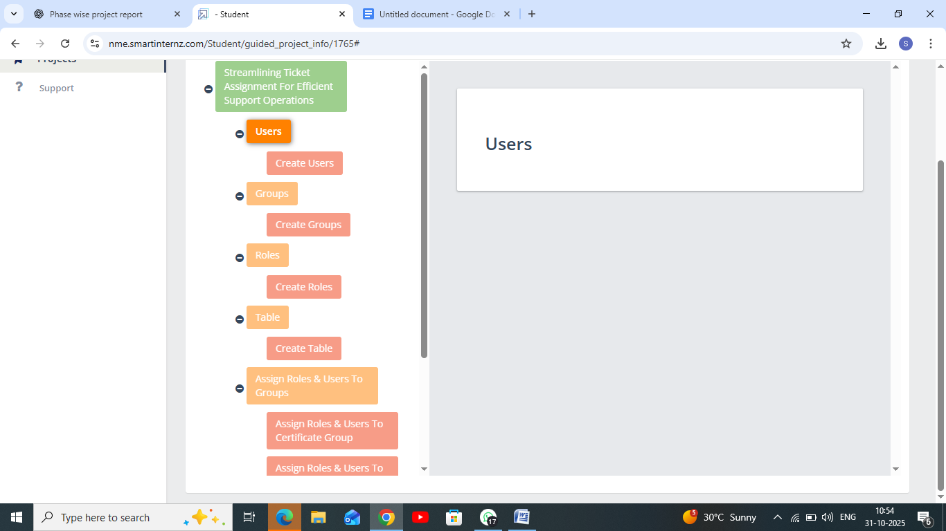

Expected Outcomes :
• Accurate and fast routing of support tickets.
• Reduced manual workload and human error.
• Improved service response time and customer satisfaction.
• Secure, role-based access to operational data.

